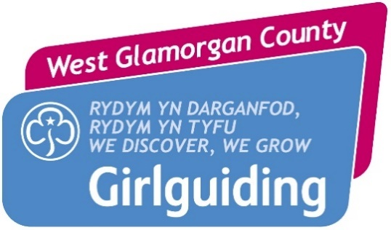
Unit application form - financial support 2021

Must complete in Full do not leave BLANKS
This form should be:
- completed by the unit leader/unit treasurer
- signed by the unit leader
- sent to the local commissioner

Name of unit
District
Division
Date of application
Does the unit claim gift aid?
Is the unit up to date with its gift aid claims?
If you answered no, please give date gift aid was last received?
Has the unit made any applications to external bodies for financial support?
If yes, who did the unit approach and what response was received?
Amount of financial support applied for?
Total price of Invoice
% percentage of Invoice

If requesting partial payment, County will pay in full and Unit will submit their part payment to County immediately as the first repayment.

Name of unit bank account:

Account Number:
Sort Code:
How do you plan to repay this loan to County ?
Units must email copy of their Invoice to countymoney.wg@outlook.com as soon as Invoices are issued

Before sending to the Local Commissioner or Treasurer please make sure a copy of each of the following documents is attached:
- Verified 2019-unit Accounts
- Bank statement (no earlier than November 2020) for every bank account held by the unit
- 2021 Census Invoice (if available)

Once completed please sign as below and send this form to your district commissioner. By signing you give your consent to:
Girlguiding West Glamorgan County collecting my details via this form. I understand that the information provided will be processed by Girlguiding West Glamorgan County in accordance with General Data Protection Requirements, that the data will only be used for processing my application and that it will not be shared with other organisations or kept for longer than necessary for this purpose. Full details are included in the Girlguiding West Glamorgan County Privacy Notice available on request.

Name
Email address
GO membership number
Signed
Date

For completion by District only

Application approved
Amount approved
Signed
Name and role
If not approved in full, action taken eg:
- referral to division or
- application rejected and reasons why
- more information requested

Please note: any applications that need to be forwarded to county for consideration must arrive BEFORE 22 February 2021.

